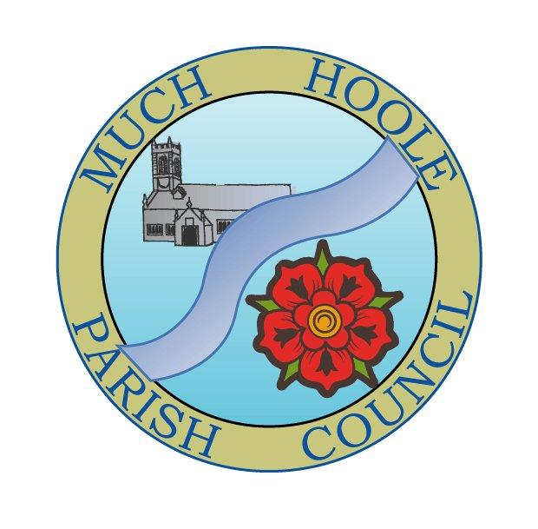 | MUCH HOOLE PARISH COUNCIL  NOTICE OF MEETING
You are hereby summoned to attend the Meeting of Much Hoole Parish Council to be held at 7.30pm on Monday, 9th January 2023. The meeting will be held at the Venue (Hoole memorial village hall) Liverpool Road.
Russ Weaver, Clerk

AGENDA
1. | Apologies for Absence  To receive apologies for absence.
2. | Declaration of Interests and Dispensations  - To receive declarations of interest from Councillors on items on the agenda  - To receive written requests for dispensations for disclosable pecuniary interests (if any)  - To grant any requests for dispensation as appropriate
3. | Minutes of the Previous Meetings  To resolve to approve as a correct record the Minutes of the Council Meeting held on the 14th December 2022
4. | Public Time  To invite and listen to issues raised by members of the public.
5. | Reports from other meetings  The Council will receive reports from meetings where Councillors have attended as representatives.
6. | Off Road Cycle Track  To consider any updates on the Cycle track and resolve any actions required.
7. | Finance and Audit  To resolve to authorise payment of the following:  - Pay the Clerk in sum of £264.25 (net pay for December 2022)  - Pay the clerk in sum of £36.00 for mileage (Sept 2022 to Jan 2023 inclusive) and £20.00 for printer ink and paper expenses  - Pay HMRC in sum of £66.00 (for December pay)  - To resolve to accept the terms of reference/letter of engagement for internal audit
8. | Review of policies  To note the below policies and approve them for continued use, or suggest any amendments  - Financial regulations  - Standing orders  - Risk register  - Asset register
9. | Planning  There are no Much Hoole planning applications
10. | Village Hall development update  To receive and note a report on the progress of The Venue
11. | Footpaths  To receive an update on any footpath repair or maintenance issues. Councillors are reminded to submit any outstanding expenses for materials from previous footpath repairs
13. | Items for next agenda
14. | Date of Next Meeting  The Parish Council to agree the date of the next meeting as 7.30pm Monday 2022, to be held at ‘The Venue’, Liverpool Road, Much Hoole.

